Department of Computer Science and Engineering (Data Science)
CSDS-A | Batch A6 (CSE - Data Science, Section A)
ClauseGuard: Legal Contract Complexity and Predatory Clause Detector
(ClauseGuard)
S.No. | Student name | Roll / hall ticket no.
1 | CH.PRANATHI | 23K91A6744
2 | G.PRANAVI | 23K91A6762
3 | G.CHARAN JOSEPH | 23K91A6753
4 | G.BHAGWATH | 23K91A6760
Under the guidance of: [GUIDE NAME], [DESIGNATION]
DESIGN AND IMPLEMENTATION
This document describes the design of ClauseGuard and how it was implemented: the architecture, the modules, the database schema, the API, key code walkthroughs, and the reasoning behind the main implementation decisions.

1 System Architecture
ClauseGuard is a single-machine web application: a React front end, a FastAPI back end, a SQLite database and a client for the Google Gemini API. It contains no model that was trained for this project; the two learned components, the embedding model and the text model, are remote services. The figure below shows the layers.
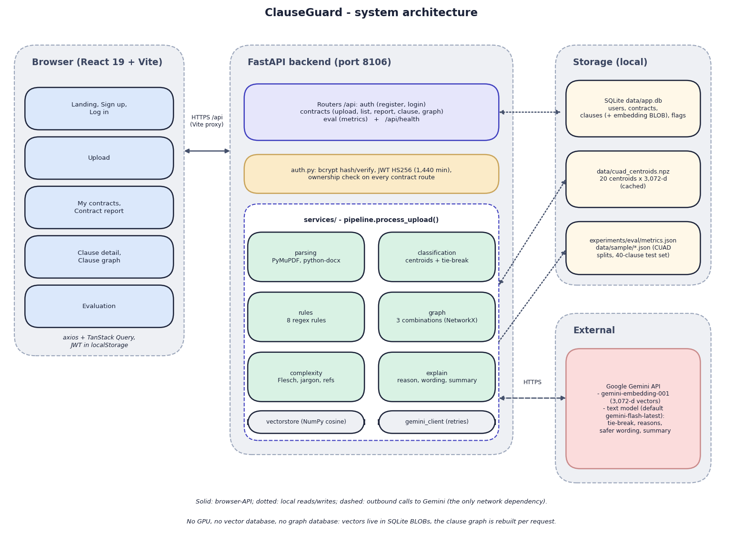
Fig. 1: System architecture of ClauseGuard
The diagram shows four zones. On the left is the browser: a React 19 single-page application built with Vite. Its pages are grouped as landing, sign-up and log-in; upload; my contracts and the contract report; clause detail and clause graph; and the evaluation page. The application talks to the server through Axios and TanStack Query, and it keeps the JSON Web Token in the browser's local storage. In development the Vite server on port 5106 proxies every /api call to the backend, so the browser sees one origin.
In the centre is the FastAPI backend on port 8106. A thin router layer (auth, contracts and eval, plus /api/health) validates requests; auth.py hashes passwords with bcrypt, signs HS256 tokens and is the dependency that identifies the caller, and every contract route checks that the contract belongs to that caller. Below it, pipeline.process_upload() orchestrates six services: parsing (PyMuPDF and python-docx), classification (centroids and an optional tie-break), the eight regular-expression rules, the NetworkX combination graph, the complexity score and the explanation service that writes the wording. Two helpers sit underneath: the NumPy cosine routines and the Gemini client with its retries.
On the right, local storage holds the SQLite file data/app.db (users, contracts, clauses with their embedding blobs, flags), the cached centroid file data/cuad_centroids.npz, and the JSON files that carry the CUAD splits, the 40-clause test set and the evaluation results. The only external dependency is the Google Gemini API, called over HTTPS for embeddings (gemini-embedding-001, 3,072 values per vector) and for text (tie-break, reasons, safer wording and summaries). The footnote of the figure states what the design does not contain: no vector database and no graph database.
The design follows five principles. Decide with rules, explain with a language model. Whether a clause is predatory is decided by a deterministic, auditable rule, so the same clause always gives the same flag; Gemini only writes the reason, quotes the trigger and drafts the safer wording. Keep every claim traceable. Each flag stores the rule id, the clause and the page, and the interface repeats this to the user. Enforce ownership on the server. The browser hides other users' contracts, but the decision is made by _get_owned_contract() in the API, which returns 404 for a contract of another user. Keep storage local and simple. Vectors are float32 blobs in SQLite and the clause graph is rebuilt per request, which removes the need for a vector or graph server at the cost of linear scans and no graph persistence. Isolate the network dependency. Gemini is reached through one module (gemini_client.py), so the model names, the retry policy and a future replacement of the provider are confined to a single file.
The design differs from the abstract of the project in three places that should be stated here: the abstract names the Claude API, pgvector and Neo4j, while the build uses Gemini, SQLite with NumPy, and NetworkX. The reasons and consequences are discussed in Chapters 1 and 6.

2 Module Design
Table 1: Modules of ClauseGuard
Module | Code (lines) | Responsibility
Application | backend/app/main.py (35) | Creates the FastAPI app, CORS, table creation at start-up and /api/health; includes the three routers
Configuration | app/config.py (28) | Reads .env: Gemini key and model names, ports, JWT secret and lifetime; creates the data, upload and experiment folders
Database | app/db.py (103) | Engine, session dependency and the four models (User, Contract, Clause, Flag)
Security | app/auth.py (47) | bcrypt hashing and checking, HS256 token creation and decoding, get_current_user dependency
Schemas | app/schemas.py (79) | Pydantic request and response types (registration with e-mail and 6-character password, report, clause, flag)
Auth routes | app/routes/auth.py (33) | POST /api/auth/register and /login
Contract routes | app/routes/contracts.py (133) | Upload with validation, list, report, clause detail, graph, ownership check
Evaluation route | app/routes/eval.py (22) | Serves experiments/eval/metrics.json
Parsing | app/services/parsing.py (95) | PDF and DOCX text extraction, heading-based segmentation with paragraph fallback
Classification | app/services/classification.py (109) | Centroid cache, nearest-centroid classification, Gemini tie-break, confidence floor
Rules | app/services/rules.py (134) | The eight predatory-clause rules with severity and legal basis; detect_flags()
Combination graph | app/services/graph.py (79) | Three risky combinations, NetworkX graph, JSON for the interface
Complexity | app/services/complexity.py (110) | Flesch reading ease, legalese density, cross-references, sentence length, weighted score and grade
Explanation | app/services/explain.py (54) | Prompts for the reason, provision and safer wording of a flag and for the contract summary
Gemini client | app/services/gemini_client.py (65) | Embedding and text calls, three retries, JSON extraction
Vector store | app/services/vectorstore.py (31) | float32 blob conversion and cosine similarity with NumPy
Pipeline | app/services/pipeline.py (89) | process_upload(): the loop over clauses, combinations, score, summary, commit
Evaluation | ml/eval.py (144) | Rule precision, recall and F1 on the 40-clause set; CUAD top-1 and top-3; writes metrics.json
Data scripts | scripts/build_cuad_samples.py (82), download_data.py (43), smoke_test.py (149) | Seeded CUAD train and held-out split, corpus download, live end-to-end smoke test
Tests | tests/ (5 files) | 68 passing tests and 5 expected failures, with Gemini stubbed
Web application | frontend/src/ (56 files, 4,507 lines) | 9 pages, 17 interface-kit components, motion and landing components, the API client, authentication and theme providers

The backend application code is about 1,250 lines in 17 files. The directory backend/app/services holds all of the analysis logic; the routers contain no business rules except the ownership check and the status-code mapping.

3 Database Design
The database is SQLite, created by SQLAlchemy 2 at start-up with create_all; there are no migrations. Results that are read and written whole (the key obligations and the risky combinations of a contract) are stored as JSON text. The uploaded file itself is not kept: it is written to data/uploads under a random name, parsed and deleted, and only its clause text, vectors and flags remain.
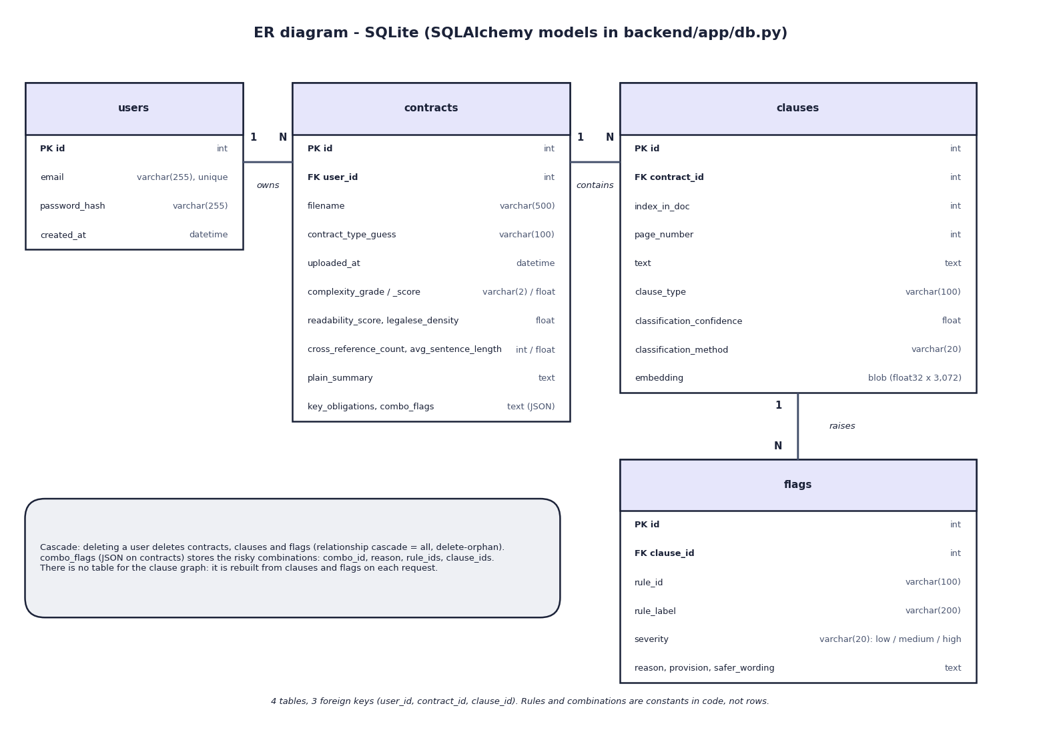
Fig. 2: Entity-relationship diagram
The database has four tables joined by three one-to-many relations: a user owns many contracts, a contract contains many clauses, and a clause raises many flags. The foreign keys are contracts.user_id, clauses.contract_id and flags.clause_id. The two JSON values of a contract (key_obligations and combo_flags) are stored as text columns, and the clause vector is a float32 blob of 3,072 values. The box in the figure notes that deleting a user cascades to everything below it through the SQLAlchemy relationships, and that the clause graph has no table because it is rebuilt from clauses and flags whenever it is requested.
Table 2: Database tables
Table | Purpose | Columns
users | Accounts | id (PK), email (unique, indexed), password_hash (bcrypt, 255), created_at
contracts | One analysed contract | id (PK), user_id (FK users), filename, contract_type_guess (default "general"; never set by any code), uploaded_at, complexity_grade, complexity_score, readability_score, legalese_density, cross_reference_count, avg_sentence_length, plain_summary, key_obligations (JSON text), combo_flags (JSON text)
clauses | One segmented clause | id (PK), contract_id (FK), index_in_doc, page_number, text, clause_type (one of 20 CUAD labels or "Other / Unclassified"), classification_confidence (cosine), classification_method ("embedding" or "gemini_tiebreak"), embedding (float32 blob, 3,072 values = 12,288 bytes)
flags | One rule hit on one clause | id (PK), clause_id (FK), rule_id, rule_label, severity (low, medium, high), reason, provision, safer_wording

Four design points should be noted. First, the relationships carry cascade="all, delete-orphan" in SQLAlchemy, so deleting a user removes their contracts, clauses and flags, but no foreign key declares an ON DELETE rule in SQLite itself and no route offers deletion. Second, the combinations are kept as JSON in contracts.combo_flags (combination id, reason, rule ids, clause ids); the clause graph is derived from clauses, flags and this column on every request, so there is no graph table and no graph database. Third, the foreign keys are not indexed, which is acceptable for the measured sizes (a report of eleven clauses is returned in a median of 9.3 ms) but would matter at scale. Fourth, the severity and the classification method are plain strings, not enumerations, and timestamps use datetime.utcnow. Passwords are never stored in clear text.

4 Application Architecture
Fig. 3: System architecture of ClauseGuard
The backend is a FastAPI application organised in three layers. Routers in routes/ (auth, contracts, eval) validate input, map exceptions to status codes and check ownership; the analysis logic lives in services/, where pipeline.process_upload() calls parsing, classification, the rules, the combination graph, the complexity score and the explanation service; and db.py defines four SQLAlchemy models over SQLite. Pydantic schemas in schemas.py define the request and response types, auth.py holds the password and token helpers, and config.py reads the settings from .env. The centroid matrix is loaded lazily on the first classification and cached in memory; Gemini is configured on the first call.
The frontend is a single-page React 19 application built with Vite. React Router defines the public and the protected routes, TanStack Query fetches and caches the API data, Axios attaches the bearer token and raises a session-expired event on a 401 from a protected call, Recharts draws the severity chart, and Tailwind CSS 4 with Radix primitives provides the components; Framer Motion, GSAP and Lenis supply the motion on the landing page. The token and the e-mail are kept in local storage. The Vite development server proxies /api to the backend, so the browser uses one origin.
Table 3: Technology stack of the implementation
Layer | Technology | Version
Language and runtime | Python; Node.js | 3.11.9; 24.19.0
Web framework | FastAPI with uvicorn; python-multipart; email-validator | 0.115.0; 0.30.6; 0.0.9; 2.2.0
Database | SQLAlchemy over SQLite | 2.0.35
Documents | PyMuPDF; python-docx | 1.24.10; 1.1.2
Numerics and graph | NumPy; NetworkX | 1.26.4; 3.3
Language model | google-generativeai (Gemini API client) | 0.8.3
Security | PyJWT (HS256); bcrypt | 2.9.0; 4.2.0
Frontend | React; Vite; Tailwind CSS; TanStack Query; React Router; TypeScript | 19.3.1; 6.4.4; 4.3.3; 5.104.2; 8.4.0; 7.0.2
Size | Backend application code; frontend sources | about 1,250 lines in 17 files; 56 files, 4,507 lines

The pages follow the user's task. Public: landing (with the measured scores of the rule evaluation), sign-up, log-in and evaluation. Signed in: My contracts, Upload contract, the contract report, the clause detail page and the clause graph.

5 API Design
The API is REST over JSON under /api: nine endpoints and no WebSocket. Interactive documentation is generated by FastAPI at /docs. Every endpoint except health, registration, log-in and the evaluation results needs Authorization: Bearer <token>. Errors have the form {"detail": "message"}; the status codes in the table are those returned by the code or observed in the tests.
Table 4: API endpoints
Method | Path | Auth | Purpose and responses
GET | /api/health | no | {status, gemini_configured, port}
POST | /api/auth/register | no | {email, password >= 6} returns {token, email, user_id}; 400 if the e-mail exists; 422 for an invalid e-mail or short password
POST | /api/auth/login | no | Returns {token, email, user_id}; 401 for a wrong password or unknown e-mail
POST | /api/contracts/upload | yes | Multipart file (.pdf or .docx): full pipeline, returns the report; 503 without an API key, 400 for another extension or no readable clause, 502 when Gemini fails
GET | /api/contracts | yes | The caller's contracts: id, filename, uploaded_at, grade, score, flag_count
GET | /api/contracts/{id} | yes | Report: grade, score, four component values, plain_summary, key_obligations, combo_flags, clause summaries; 404 if not the caller's
GET | /api/contracts/{id}/clauses/{cid} | yes | Clause text, type, confidence, method, flags with reason, provision and safer_wording; 404
GET | /api/contracts/{id}/graph | yes | Nodes, edges and risky combinations; 404
GET | /api/eval/metrics | no | Contents of experiments/eval/metrics.json with available: true, or a message when no evaluation has been run

Example: the report of an upload. An abbreviated response for the invented freelance contract:
Listing: Upload response (shape, abbreviated)
POST /api/contracts/upload (multipart: file = freelance_services_agreement.docx)
-> 200 {"id": 1, "filename": "freelance_services_agreement.docx",
"complexity_grade": "B", "complexity_score": 23.3, "readability_score": 39.8,
"legalese_density": 0.71, "cross_reference_count": 0, "avg_sentence_length": 16.2,
"plain_summary": "...", "key_obligations": ["...", "..."],
"combo_flags": [{"combo_id": "termination_norefund_penalty", "rule_ids": [...], "clause_ids": [2, 3, 4], "reason": "..."}, ...],
"clauses": [{"id": 1, "index_in_doc": 0, "page_number": 1, "clause_type": "Ip Ownership Assignment",
"text_preview": "...", "flag_count": 0, "max_severity": "none"}, ...]}

Example: a clause. GET /api/contracts/1/clauses/2 returns the clause with flags: [{rule_id: "unilateral_termination", rule_label, severity: "high", reason, provision, safer_wording}]. Reason, provision and safer wording are the text returned by Gemini; the rule id, label and severity come from the rule. A caller who requests a contract or clause of another user receives 404, not 403, so the existence of the contract is not revealed.
The cost of an upload grows with the content: the server makes one embedding call per clause, one text call per flag and one for the summary, one after the other. The measured eleven-clause contract with eight flags took 113.6 s, which is inside the 180 s client timeout but leaves little margin.

6 Key Code Walkthroughs

6.1 Segmentation
The splitter keeps a page as one clause list when it finds at least two numbered headings, which is also why text before the first heading is lost: the first chunk starts at the first match.
Listing: Heading-based segmentation in services/parsing.py
def _split_page_text(text: str) -> list[str]:
headers = list(CLAUSE_HEADER_RE.finditer(text))
if len(headers) >= 2:
chunks = []
for i, m in enumerate(headers):
start = m.start()
end = headers[i + 1].start() if i + 1 < len(headers) else len(text)
chunks.append(text[start:end])
return chunks

6.2 Classification
The clause is ranked against the centroids; the tie-break is attempted only when both conditions hold, and any Gemini failure silently falls back to the embedding result.
Listing: Nearest centroid, tie-break and floor in services/classification.py
sims = cosine_similarity_matrix(embedding, centroids)
order = np.argsort(-sims)
top1_idx, top2_idx = int(order[0]), int(order[1])
top1_sim, top2_sim = float(sims[top1_idx]), float(sims[top2_idx])

method = "embedding"
label = categories[top1_idx]
confidence = top1_sim

if top1_sim - top2_sim < TIE_BREAK_MARGIN and top1_sim < 0.60:
top3_idx = [int(i) for i in order[:3]]
candidates = [categories[i] for i in top3_idx]
try:
label, confidence = _tie_break(text, candidates, top1_sim)
method = "gemini_tiebreak"
except Exception: # noqa: BLE001 - fall back to embedding result
pass

if confidence < 0.35:
label = UNKNOWN_LABEL

return {
"clause_type": label,
"confidence": round(float(confidence), 3),
"method": method,
"embedding": embedding,
}

6.3 A rule
A rule bundles an id, a label, a severity, the stated legal basis and the compiled pattern; detect_flags() is a one-line filter over the list of rules.
Listing: The no-refund rule in services/rules.py
Rule(
id="no_refund",
label="No-Refund Clause",
severity="medium",
legal_basis="Consumer Protection Act 2019 - blanket no-refund terms, especially combined with "
"unilateral termination, can constitute an unfair trade practice.",
pattern=re.compile(
r"non[- ]refundable|no\s+refund(?:s)?\s+(?:shall|will)\s+be\s+(?:made|given|provided|issued)|"
r"not\s+entitled\s+to\s+(?:any\s+)?refund",
re.IGNORECASE,
),
),

Listing: Rule application in services/rules.py
def detect_flags(clause_text: str) -> list[Rule]:
return [rule for rule in RULES if rule.pattern.search(clause_text)]

6.4 Risky combinations
The rule ids found anywhere in the contract are collected, and a combination fires when all of its rule ids are present; the clauses involved are those carrying any of them.
Listing: Combination detection in services/graph.py
def detect_risky_combinations(clauses: list[dict]) -> list[dict]:
"""clauses: list of {id, flags: [rule_id, ...]}. Returns list of
{combo_id, reason, clause_ids: [...]} for each combo whose rule_ids are all
present somewhere in the contract (possibly on different clauses)."""
rule_to_clauses: dict[str, list[int]] = {}
for c in clauses:
for rule_id in c["flags"]:
rule_to_clauses.setdefault(rule_id, []).append(c["id"])

present_rules = set(rule_to_clauses.keys())
hits = []
for combo in RISKY_COMBOS:
if combo["rule_ids"].issubset(present_rules):
clause_ids = sorted({cid for rid in combo["rule_ids"] for cid in rule_to_clauses[rid]})
hits.append({
"combo_id": combo["id"],
"reason": combo["reason"],
"rule_ids": sorted(combo["rule_ids"]),
"clause_ids": clause_ids,
})
return hits

6.5 Complexity score
The four lexical measures are turned into difficulty values and combined with fixed weights; the grade is a lookup on the result.
Listing: Weighted complexity score in services/complexity.py
readability_difficulty = 100 - readability
legalese_difficulty = min(100.0, legalese * 8)
cross_ref_difficulty = min(100.0, (cross_refs / max(num_clauses, 1)) * 40)
sentence_difficulty = min(100.0, max(0.0, (avg_sent - 15) * 3))

complexity_score = round(
0.35 * readability_difficulty
+ 0.30 * legalese_difficulty
+ 0.20 * cross_ref_difficulty
+ 0.15 * sentence_difficulty,
1,
)

6.6 The pipeline loop
One loop classifies, flags and explains each clause; a Gemini failure raises out of the loop and, because the commit comes last, nothing is saved.
Listing: Per-clause processing in services/pipeline.py
for raw in raw_clauses:
result = classification.classify_clause(raw["text"])
clause = Clause(
contract_id=contract.id,
index_in_doc=raw["index_in_doc"],
page_number=raw["page_number"],
text=raw["text"],
clause_type=result["clause_type"],
classification_confidence=result["confidence"],
classification_method=result["method"],
embedding=to_blob(result["embedding"].tolist()),
)
session.add(clause)
session.flush()
clause_records.append(clause)

matched_rules = detect_flags(raw["text"])
rule_ids = []
for rule in matched_rules:
explanation = explain.explain_flag(raw["text"], rule)
flag = Flag(
clause_id=clause.id,
rule_id=rule.id,
rule_label=rule.label,
severity=rule.severity,
reason=explanation["reason"],
provision=explanation["provision"],
safer_wording=explanation["safer_wording"],
)
session.add(flag)
rule_ids.append(rule.id)
flags_summary.append({
"rule_label": rule.label,
"severity": rule.severity,

6.7 Ownership check and token guard
Listing: Ownership check in routes/contracts.py
def _get_owned_contract(session: Session, contract_id: int, user_id: int) -> Contract:
contract = session.get(Contract, contract_id)
if not contract or contract.user_id != user_id:
raise HTTPException(status_code=404, detail="Contract not found.")
return contract

Listing: Authentication dependency in auth.py
def get_current_user(
credentials: HTTPAuthorizationCredentials = Depends(security),
session: Session = Depends(get_session),
) -> User:
payload = decode_token(credentials.credentials)
user = session.get(User, int(payload["sub"]))
if not user:
raise HTTPException(status_code=status.HTTP_401_UNAUTHORIZED, detail="User not found")
return user

Listing: Gemini call with retries in services/gemini_client.py
def _call_model(prompt: str, retries: int = 3) -> str:
_ensure_configured()
model = genai.GenerativeModel(GEMINI_TEXT_MODEL)
last_err = None
for attempt in range(retries):
try:
response = model.generate_content(prompt)
return response.text or ""
except Exception as exc: # noqa: BLE001
last_err = exc
time.sleep(1.5 * (attempt + 1))
raise RuntimeError(f"Gemini generate_content failed after {retries} attempts: {last_err}")

7 Implementation Decisions and Reasoning
The table lists the main implementation decisions and the reason for each. Several are consequences of three constraints: the build had to run on one ordinary computer without a graphics card, the only language model available was a shared free-tier Gemini key, and no labelled corpus of Indian contracts existed.
Table 5: Implementation decisions
Decision | Why (and what it costs)
Decide 'predatory or not' with eight regular expressions; use Gemini only to word the reason, quote the provision and draft a safer clause | The verdict is auditable, repeatable and needs no API call, so it can be tested offline (73 automated test cases, ml/eval.py). The cost is recall: keyword-free paraphrases are missed (independent probe recall 0.458)
Tie each rule to an Indian statute (Indian Contract Act 1872 sections 27, 73 and 74 [20]; Arbitration and Conciliation Act 1996 [21]; Consumer Protection Act 2019 [22]; Copyright Act 1957 [23]) | The rule's legal_basis text is placed in the explanation prompt, so the generated reason names the right provision. It is grounding by prompt, not retrieval from a legal corpus, which the build does not have
Classify by the nearest of 20 category centroids of Gemini embeddings [13] instead of training a classifier | 25 labelled CUAD spans per category give a usable centroid with no training and no fitted model file beyond a cached array; a logistic regression on the same vectors is only 0.008 better in top-1 (0.800 against 0.792)
Use 20 substantive CUAD categories, not all 41 | Administrative categories (document name, parties, dates) are metadata rather than clause types; the 20 chosen categories are the ones a signatory cares about
Embeddings from the Gemini API (3,072 dimensions) instead of a local sentence encoder [12] | No model download or GPU is needed; the cost is a network dependency, free-tier limits and about 0.7 s per clause
Keep vectors in SQLite as float32 blobs and compare with NumPy, not pgvector | There is no database server to install and a contract has tens to hundreds of clauses, so a brute-force cosine is instant. The stored clause vectors are written but never read again by the application; they would matter only for cross-contract search
Rebuild the clause graph per request with NetworkX [16] and three fixed combination patterns, not Neo4j | The graph is cheap and derived from the stored flags, so nothing needs persisting. The cost is that the graph holds no legal concepts or precedents and a combination fires on rule ids anywhere in the contract, whatever the distance between the clauses
Complexity score as a weighted sum of four lexical measures (0.35 Flesch [15], 0.30 legalese density, 0.20 cross-references, 0.15 sentence length) with grade cut-offs at 20, 40, 60 and 80 | Readable, cheap and explainable on the report. The weights and cut-offs were chosen by the authors and never validated against human ratings
Segment by numbered headings, falling back to blank-line paragraphs of about 400 characters; PDF per page, DOCX as one page | Simple and page-aware. It drops text before the first heading, ignores Article I style headings (84 of 510 CUAD contracts give fewer than five clauses) and splits clauses that cross a page
Constants for the tie-break (margin 0.03, similarity 0.60) and the floor (0.35) | Intended to hand ambiguous clauses to the language model and to refuse clearly unrelated ones. With the current embedding model similarities lie between 0.657 and 0.849, so neither ever acts; they were not calibrated
Model names and key from .env; override of GEMINI_TEXT_MODEL for one process | The default gemini-flash-latest timed out on the free tier at the start of the run (20 requests per day per model), so the demonstration backend was started with gemini-3.1-flash-lite without changing any file. The shipped .env.example still names two retired models (gemini-2.0-flash, models/text-embedding-004)
FastAPI, SQLAlchemy and SQLite; JWT (HS256, 1,440 minutes) [19] and bcrypt [18] | Typed request and response models, no database server, stateless tokens and slow password hashing; every contract route checks ownership and answers 404 for other users' contracts so that their existence is not revealed
Write the upload to a random file name, delete it in a finally block, commit once at the end | A failure in Gemini or in the pipeline leaves no contract row and no file behind (tested); the price is that a long analysis is lost entirely when its last call fails
React 19, Vite and TanStack Query with a 180 s upload timeout and a dev-server proxy for /api | One origin for the browser and a response cache for the report screens; the timeout is shorter than the upload of a contract with about 14 flags
No fake data path; the Evaluation page reads experiments/eval/metrics.json | Every number on screen comes from the real pipeline or a real evaluation run, but the page also repeats the claim 'held-out set' for a development set

8 Security and Error Handling
- Passwords are hashed with bcrypt [18] before storage; registration requires a syntactically valid e-mail address (validated by the email-validator package) and a password of at least six characters. The hash check costs about 255 ms, which slows brute-force attempts.
- Tokens. A signed JSON Web Token [19] (HS256, PyJWT) with the user id and e-mail and an expiry of 1,440 minutes is issued at registration and log-in; every contract route decodes it and loads the user, and an invalid, expired or forged token, or a token for a deleted user, returns 401. A request without any token returns 403 (observed: 403 in 1.8 ms).
- Ownership. _get_owned_contract() returns 404 for a contract that does not belong to the caller, for the report, the clause and the graph routes alike; the list route filters by the caller's id.
- Uploads. Only the extensions .pdf and .docx are accepted, checked by file name and not by content. The file is written under a random UUID name and removed in a finally block whether the analysis succeeds or fails.
- Atomicity. The pipeline commits once at the end; a Gemini failure raises before the commit, the session is closed without saving, and a test confirms that no half-written contract is left.
- Secrets. The Gemini key and the JWT secret are read from .env, which is excluded from version control; if JWT_SECRET is missing, config.py falls back to a fixed development value.
- Cross-origin requests are allowed from any origin (allow_origins=["*"]).
Errors. A ValueError from parsing becomes HTTP 400, a RuntimeError (the Gemini client raises it after three failed attempts) becomes HTTP 502 with the upstream message in the detail, and the missing key gives 503. By code reading, a malformed JSON answer from the model raises json.JSONDecodeError, which is a subclass of ValueError, so it would be reported as HTTP 400 and not 502; this path was not exercised. The browser translates the status codes into readable messages and shows an expired-session toast on a 401.
Known gaps, stated so that they are not mistaken for features. (1) The server does not limit the size of an uploaded file; the whole file is read into memory. (2) The file type is judged by its name only. (3) There is no rate limiting, no HTTPS in the development setup and no audit log. (4) The token is kept in the browser's local storage, where any script running on the page could read it. (5) The fallback JWT secret and the wildcard cross-origin policy are suitable for development only. (6) Contract text is sent to a third-party service (Google Gemini) for embedding, explanation and summary, and the extracted clause text is stored unencrypted in SQLite; for confidential contracts this needs an explicit decision by the user. (7) Text taken from a contract is placed in the prompts, so a contract can contain instructions addressed to the language model; the rules decide the flags, but the wording could be influenced. (8) The evaluation endpoint is public by design.

9 User Interface Design
The web application has nine pages. The public pages are the landing page, sign-up, log-in and the evaluation page. After log-in a sidebar layout offers two entries, My contracts and Upload contract, and the contract pages are reached from the list: the contract report, the clause detail page with two tabs (Flags and Clause text) and the clause graph. Four pages (landing, evaluation, contract report and clause graph) are loaded on demand, and a protected-route component sends a visitor without a token to the log-in page; the older paths /upload and /contracts redirect to the new ones.
The design decisions follow from the users, who are not lawyers. The report opens with the grade as a large badge and six figures (readability, legalese density, cross-references, average sentence length, flagged clauses and the score), followed by the plain-language summary, the key obligations and a chart of the clauses by their highest severity. Risky combinations are shown in their own warning-coloured panel. Each flagged clause shows the reason, the quoted provision and the safer wording in separate blocks, with severity as a coloured badge that is also written as a word. The upload page validates the extension in the browser, shows a progress bar and then an indeterminate bar while the server works, and states that the file is removed after analysis. The sidebar repeats the promise that every flag is tied to the exact clause and page. A theme toggle switches between light and dark.
Three limitations of the interface should be stated. The clause graph places its nodes evenly on a circle, so the position of a node carries no meaning; only the red colour and the lines between clauses of the same combination do. The upload request has a client timeout of 180 s, which a contract with many flags can exceed because the server makes one Gemini call per flag (the measured eight-flag contract needed 113.6 s). And the evaluation page describes its scores as measured "on a held-out set" although the 40 clauses behind them were written together with the rules, a point examined in Chapter 8. The screens below were captured from the running application with the three real uploads of this project; the complete set is in Chapter 8 and Appendix C.
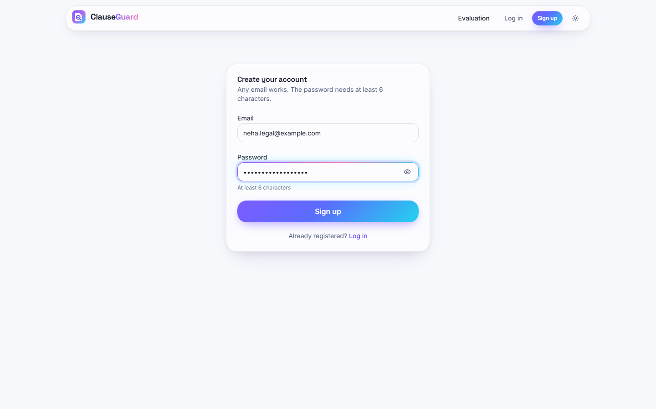  Fig. 4: Sign-up page | 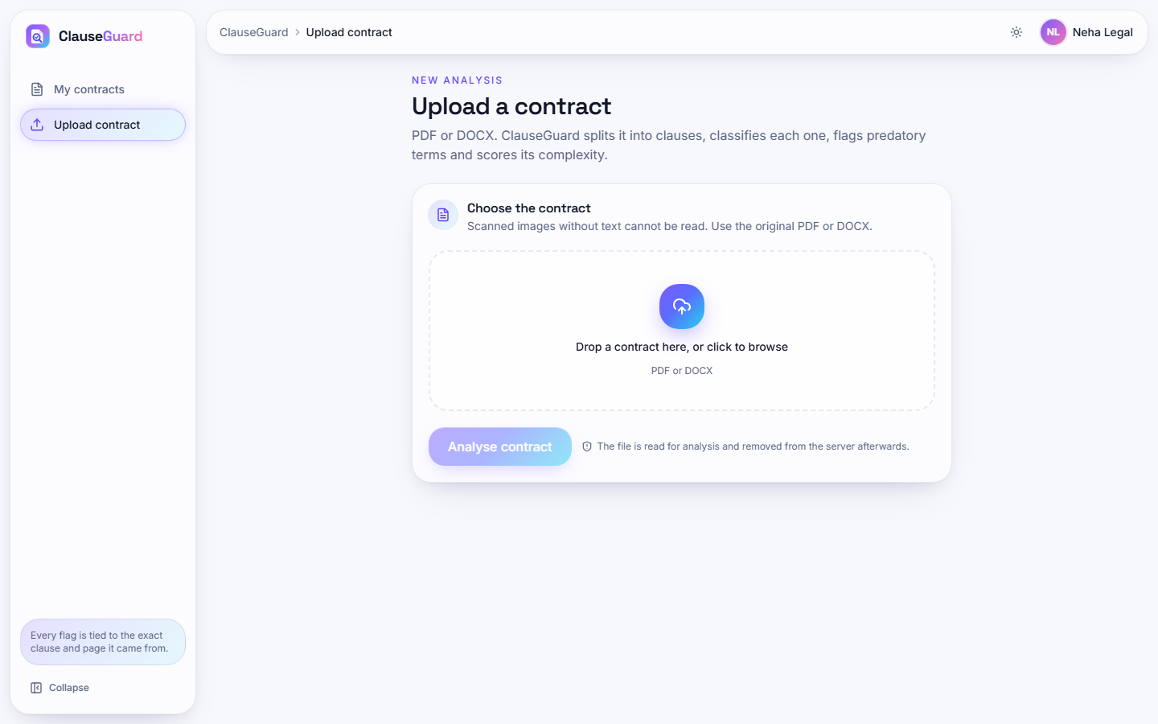  Fig. 5: Upload page before a file is chosen

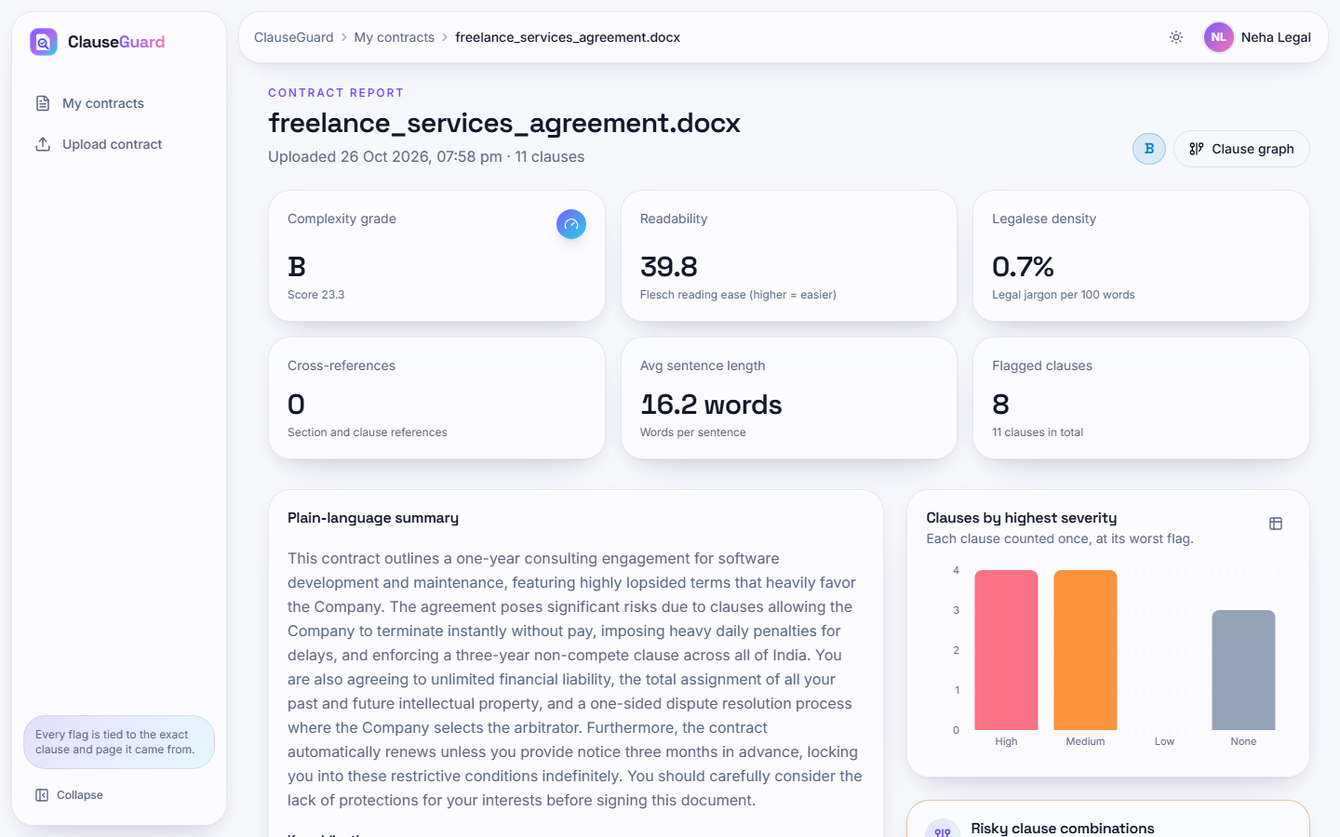  Fig. 6: Contract report: grade, six figures, summary and severity chart | 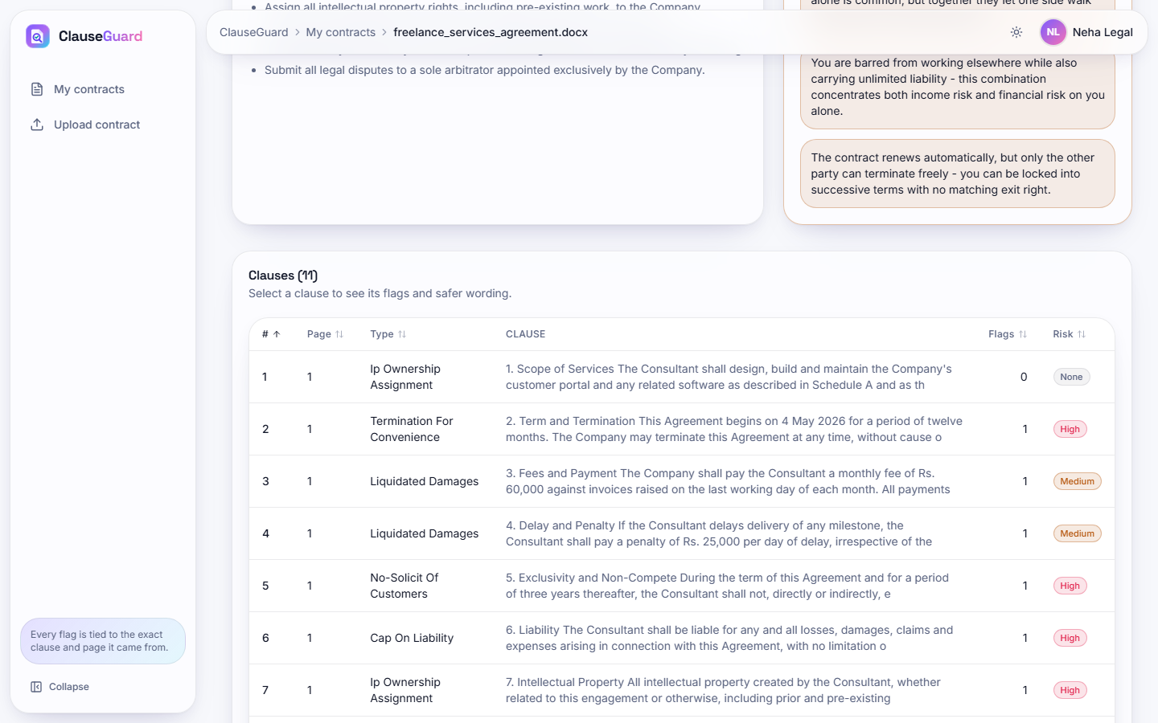  Fig. 7: Clause table with type, flags and risk

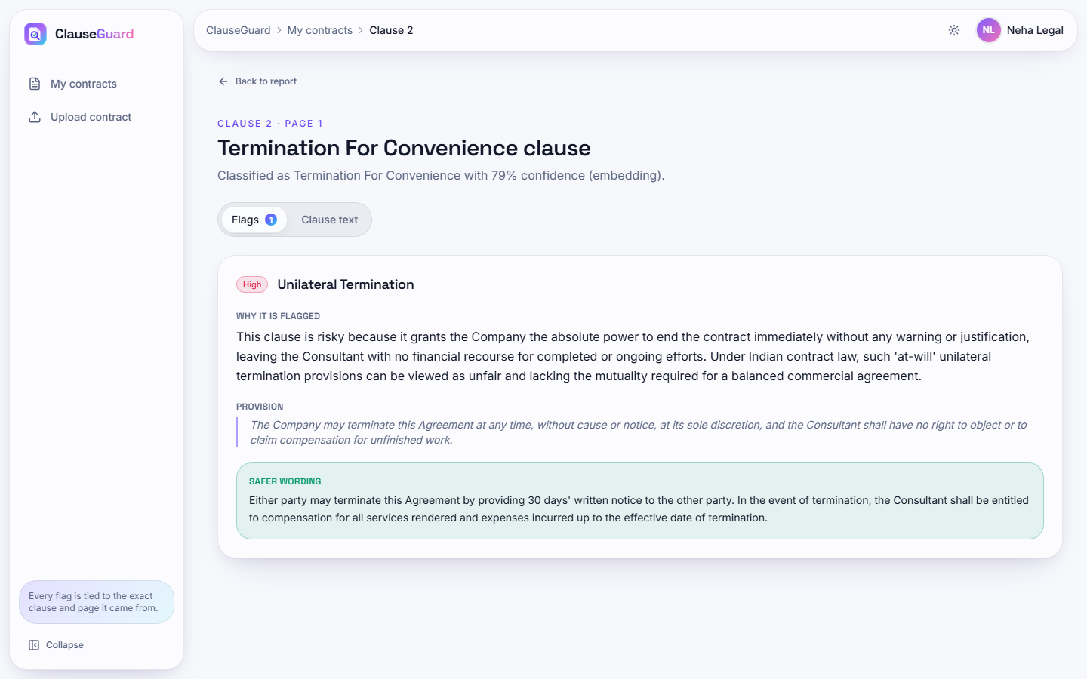  Fig. 8: Clause detail: reason, quoted provision and safer wording | 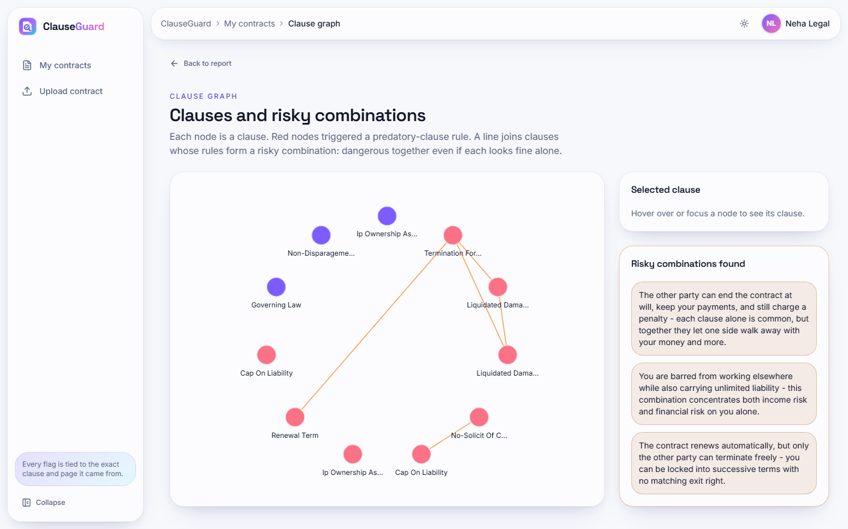  Fig. 9: Clause graph with the risky combinations

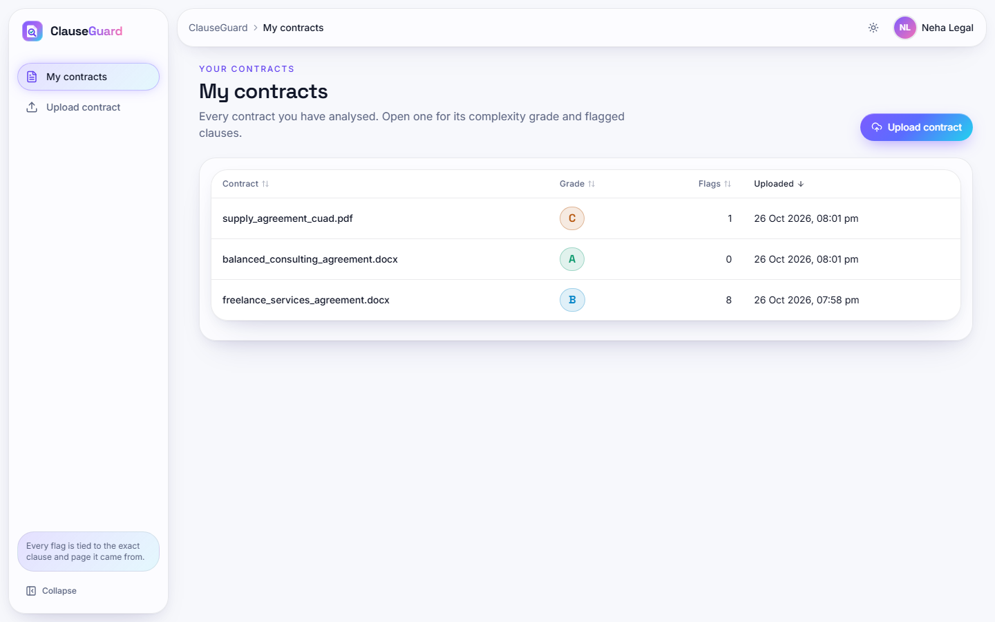  Fig. 10: My contracts list with three analysed contracts | 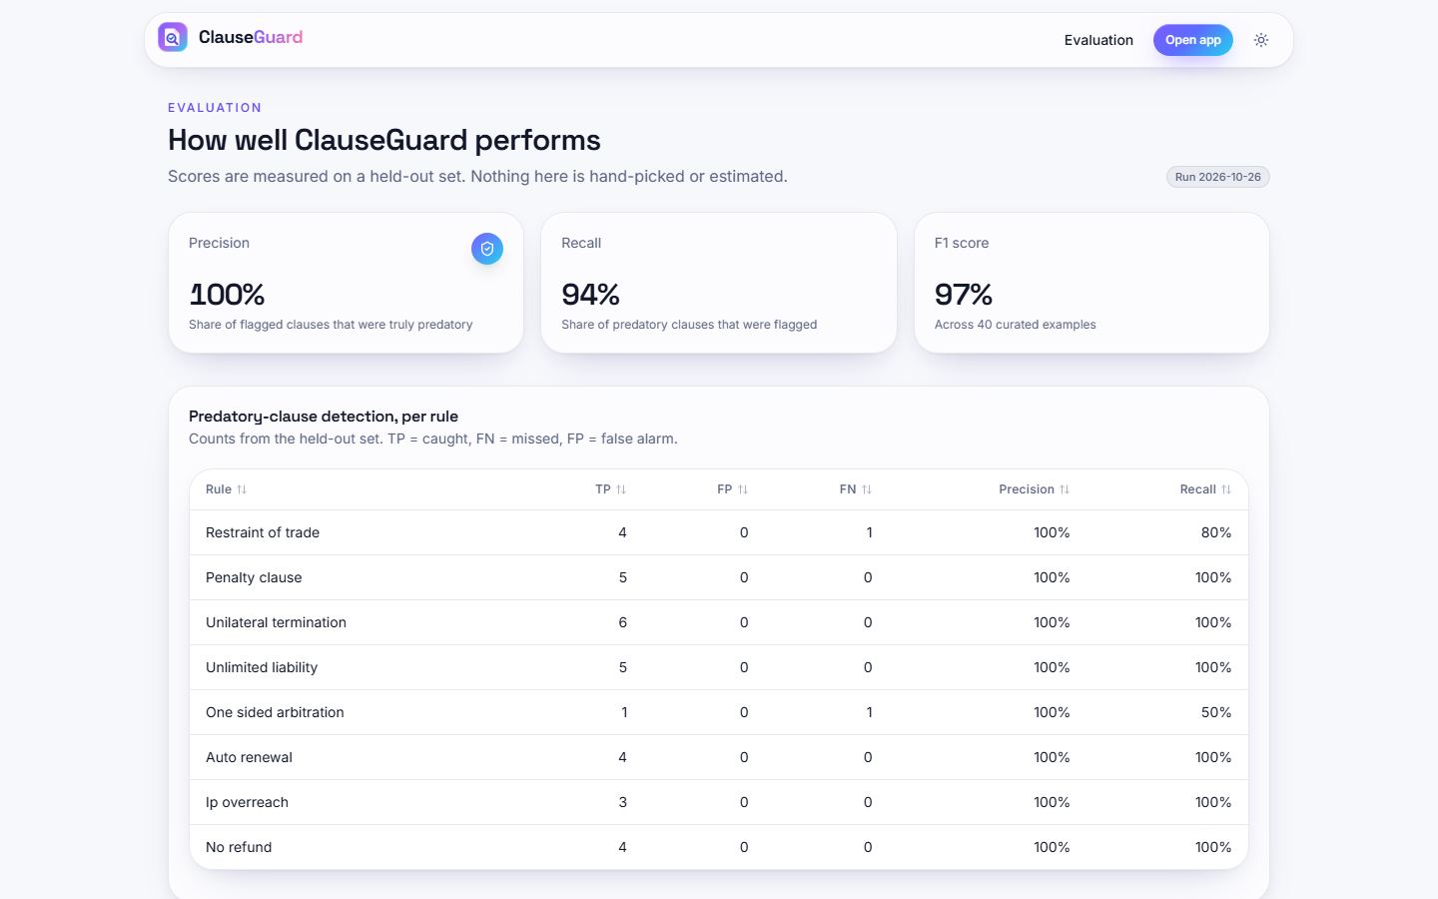  Fig. 11: Evaluation page with the measured scores

10 Installation and Execution
The application needs Python 3.10 or later (3.11.9 was used), Node.js and a Gemini API key. All commands are run from the project folder 8.ProjectCode.
Table 6: Installation and execution
Step | Command | What it does
1 | setup.bat | Creates venv, installs backend/requirements.txt, runs npm install in frontend, creates .env from .env.example if missing, and downloads CUAD if data/cuad/CUADv1.json is absent (it is committed)
2 | Edit .env: GEMINI_API_KEY, GEMINI_TEXT_MODEL, GEMINI_EMBEDDING_MODEL (models/gemini-embedding-001), JWT_SECRET | The backend reads exactly these names; the template's default model names (gemini-2.0-flash, models/text-embedding-004) are no longer served, and the GEMINI_MODEL / GEMINI_EMBED_MODEL lines at the end of the template are not read
3 | run.bat | Starts uvicorn on port 8106 and npm run dev on port 5106 in two windows and opens http://localhost:5106 (use localhost: Vite listens on the IPv6 loopback)
4 | Sign up in the browser | There is no pre-seeded account; any e-mail with a 6-character password works (reserved domains such as .local are rejected by the validator)
5 | venv\Scripts\python.exe -m pytest | Runs the 73 tests (68 pass, 5 expected failures) in about 10 s, with Gemini stubbed; needs pytest and httpx in the venv
6 | venv\Scripts\python.exe scripts\smoke_test.py | Live end-to-end test against the running API (needs a working key)
7 | venv\Scripts\python.exe ml\eval.py | Recomputes experiments/eval/metrics.json (rules; CUAD classification if a key is set)

The experiments of this chapter are reproduced with scripts/exp_embed_cache.py (needs the key and takes about seven minutes), exp_classification.py, exp_rules_corpus.py and exp_format_parity.py; the screenshots with scripts/capture_screens.py; the latency table with scripts/measure_api.py. If the default text model is over quota, set GEMINI_TEXT_MODEL in the environment of the backend process to another model; the measured runs of this project used gemini-3.1-flash-lite.
Golden path. Sign up, upload a contract, wait for the analysis (about 15 s for a short contract without flags and about two minutes for one with many), read the grade and the summary, open a flagged clause to read the safer wording, open the clause graph for the combinations, return to My contracts, and open Evaluation for the measured scores.

